**Novel Fused Filament Fabrication System for Additive Manufacturing with Minimized Support Structures**

Chung-Tao Huang1

Dian-Ru Li1,*

1 Department of Mechanical Engineering, National Taiwan University, Taipei, Taiwan

*Corresponding author: Dian-Ru Li

Department of Mechanical Engineering, National Taiwan University

No. 1, Section 4, Roosevelt Rd, Da’an District, Taipei City, 10617

Email: dianrul@ntu.edu.tw

For Submission to *Additive Manufacturing*

August, 2024

**Abstract**

This research presents a novel Minimized-Support Fused Filament Fabrication (MSFFF) system designed to address the inherent limitations of traditional Fused Filament Fabrication (FFF) technology in additive manufacturing. This MSFFF system integrates a discretized platform module and a customized extruder equipped with an actuator for platform unit lifting. By strategically positioning and lifting individual platform units, the MSFFF system significantly reduces support material usage and fabrication time. A dedicated support minimization algorithm optimizes part placement and orientation, further enhancing the system's efficiency. The modular design of the MSFFF system enables easy integration into existing FFF infrastructures, facilitating rapid implementation and reducing operational complexity. Experimental results have demonstrated the successful fabrication of parts with varying complexities, including those with intricate geometries, showcasing the system's versatility. Compared to conventional FFF, the MSFFF system demonstrated substantial reductions in both total material consumption (up to 36% reduction) and support material usage (up to 87% reduction). Fabrication time was also significantly reduced, with overall time savings of up to 33% and support material fabrication time savings of up to 72%. These improvements were achieved while maintaining comparable geometric accuracy. The near-complete elimination of support material in specific case studies highlights the system's potential for significantly enhancing the cost-effectiveness, efficiency, and sustainability of additive manufacturing processes. The developed technologies offer potential for broader application in AM processes requiring efficient support material management. This advancement signifies a significant step towards wider adoption of additive manufacturing across industries.

**Keywords**

Additive Manufacturing; Fused Filament Fabrication; Fused Deposition Modeling; Support Structure; Material Consumption; Process Optimization; Process Innovation.

1. **Introduction**

Additive Manufacturing (AM) has gained significant traction due to its inherent advantages over conventional manufacturing techniques [1–4]. These advantages include greater design freedom, enabling the fabrication of highly complex and customized parts with minimal material waste [1,5,6]. AM excels at producing components with intricate geometries, such as those featuring deep channels, twisted or contorted shapes, and high surface area-to-volume ratios. These complex geometries can be achieved with simpler operational processes and shorter lead times compared to traditional methods [6,7]. The versatility of AM machines lies in their compatibility with a wide range of materials, offering acceptable accuracy and leading to substantial benefits like reduced labor requirements, minimized time and material waste [8–12]. The aforementioned advantages have positioned AM as a transformative technology, finding widespread application in diverse fields such as aerospace [13–15], military [16] , and medical sectors [7,17,18]. Among AM technologies, Fused Filament Fabrication (FFF), also known as Fused Deposition Modeling (FDM), stands out for its operational simplicity and purported environmental benefits [19,20]. FFF facilitates the rapid and accurate fabrication of intricate geometries and complex shapes. FFF technology exhibits significant material versatility, successfully functioning with a broad range of materials including metals, polymers, and even composite filaments incorporating ceramic fillers [21]. This adaptability is a contributing factor to the extensive adoption of FFF within the AM field. Furthermore, FFF promises significant reductions in process steps and resource consumption compared to conventional manufacturing techniques [22]. The elimination of tooling requirements associated with FFF is postulated to expedite design-to-production cycles while minimizing costs [23]

FFF presents a versatile additive manufacturing technology, yet inherent limitations hinder its widespread industrial adoption. The layered nature of FFF inherently compromises dimensional accuracy and surface finish due to stepwise deposition and interlayer adhesion effects [24–26]. These factors can lead to anisotropic mechanical properties and surface texture inconsistencies [27–29]. Furthermore, FFF necessitates the use of support structures to prevent material collapse during overhangs and complex geometries [30,31]. However, support material utilization introduces additional drawbacks, including increased printing time, material waste (often non-recyclable), and energy consumption [32,33]. The complexity of a part also directly influences support material requirements, potentially extending printing times significantly compared to traditional manufacturing techniques [34–36]. Additionally, support removal is typically a manual process, sometimes requiring secondary steps or specialized tooling to maintain part integrity. This post-processing stage further increases process and labor costs, particularly for parts with intricate geometries demanding extensive support structures [31,37] . Consequently, these limitations can hinder the adoption of FFF for high-volume production scenarios involving parts with diverse geometries.

Various methods have been explored to address the challenges associated with support material usage in FFF, aiming to reduce process costs and increase throughput. One approach involves optimizing FFF process parameters to enable novel part building orientations [38–42] or specialized support structures that minimize support material requirements [19,43,44]. Jiang et al. proposed a novel support generation strategy that determines the necessity of support material based on thresholds for printable overhang angles and bridge lengths [45] . These findings established design guidelines for FFF machines to identify when support is essential for maintaining part geometry. Building upon this work, Jiang et al. introduced an innovative part slicing method that minimizes the area requiring support material in each layer [46] . This approach, based on the aforementioned thresholds, yielded reductions in material usage, fabrication time, and energy consumption by up to 46%, 33.3%, and 30.9%, respectively, for a specific circular part geometry. Sammaiah et al. investigated the influence of different support material patterns on material usage, fabrication time, and part stability for parts with large overhang angles [19]. Their findings suggest that line supports offer a significant reduction in support material usage (26%) compared to grid patterns, albeit with a trade-off in flexural strength. Vanek et al. proposed a tree-like support structure design to provide sufficient support while minimizing overall material consumption [43] . This approach achieved an average reduction of printing time (29.4%) and support material usage (40.5%). While these studies demonstrate reductions in total material use and fabrication time, the effectiveness is often highly dependent on specific part geometries. In many cases, significant support material usage remains unavoidable.

An alternative approach to minimizing support material usage explores multi-axis FFF printing processes [47–52]. These methods introduce additional rotational degrees of freedom for either the extruder or the print platform, aiming to reduce overhang angles and eliminate the need for support structures during fabrication. Coupek et al. presented a system where the traditional FFF platform was replaced with a rotating cylindrical base [47] . This approach enabled support-free printing of radially symmetric parts by ensuring material deposition perpendicular to the ever-changing print surface. Wüthrich et al. developed a 4-axis FFF system with a rotatable extruder, achieving support-free printing for overhang angles exceeding 45-60° – a significant improvement compared to the limitations of conventional 3-axis FFF [48]. Their findings demonstrated that parts printed with the 4-axis system maintained comparable geometric accuracy and surface quality to those produced with a 3-axis system. Kontovourkis et al introduced a 5-axis robotic additive manufacturing system featuring a rotating extruder head [49]. This system overcame potential material collapse due to large overhangs by optimizing tool paths for novel material deposition mechanisms, allowing for support-free printing for specific part geometries. Similarly, Jensen et al. integrated an FFF print platform onto a 6-axis robot arm [53]. The robotic arm's rotational capabilities provided base support during material deposition, eliminating the need for support structures. However, it is crucial to acknowledge that the implementation of multi-axis FFF modules or robotic systems often necessitates significant software changes and machine modifications, potentially incurring higher costs compared to the labor associated with manual support removal. Consequently, the widespread adoption of these approaches remains limited.

To improve compatibility with existing 3-axis FFF machines, researchers have explored innovative print platforms with discrete lifting units. These platforms aim to eliminate support material needs by strategically elevating specific platform regions during printing. Hongyao et al. implemented a specially designed platform comprised of several sub-platforms, each controlled by a dedicated motor mechanism [54] . This system enabled selective lifting of platform units corresponding to regions with large overhang angles, effectively negating the need for support structures. Their findings indicated reductions in material usage by up to 41% and printing time by up to 47%. Building upon this concept, Xu et al. developed a discretized print platform with a reduced number of motors for simplified control [55] . Each platform unit had pre-defined lifting heights, and all units were actuated simultaneously by a single linear motor during FFF operation, minimizing support material use. Experimental results across various test cases demonstrated an average reduction of nearly 40% in printing time and material usage, along with enhanced reliability and robustness. While these studies present innovative solutions for reducing support material use and fabrication time, the bulky platform assemblies and associated modification efforts remain significant limitations. Additionally, substantial software modifications are still necessary to achieve synchronized control of the extruder and platform movements.

This study proposes a novel minimized-support FFF (MSFFF) system to address the aforementioned limitations in current approaches. The MSFFF system prioritizes ease of implementation, portability, and configurability through its modular design. This modularity facilitates rapid integration into existing FFF infrastructures, enabling reductions in both material consumption and fabrication time. The core design of the MSFFF system comprises two key components: a discretized platform module and a customized extruder. This extruder has a specially designed housing that integrates an electromagnet for lifting purposes. The platform module itself is comprised of several configurable units. These units can be tailored to various printing requirements in terms of height and overall size. The lack of motors within the modules enhances portability by relying solely on lightweight mechanical elements. The lifting mechanism is achieved by synchronizing extruder movement with the electromagnet to attract the steel surfaces of the platform units. To ensure seamless integration with existing FFF printing workflows, a dedicated support-minimization algorithm is developed. This algorithm maintains compatibility with current FFF slicing software and enables control over the complexity of printed parts. The algorithm incorporates both the original FFF components and the newly installed modules. A comprehensive evaluation of the system's performance is conducted through specially designed test cases. These test cases involve fabricating parts with maximum overhang angles of 90 degrees and varying sizes. Material usage and fabrication time are recorded and compared between parts printed on the MSFFF system and those produced by a conventional FFF printer. Additionally, a 3D scanner is employed to assess the geometrical accuracy of printed parts, highlighting any potential deviations introduced by the MSFFF system compared to the baseline FFF printer. Finally, the system's efficacy is further validated through case studies involving two parts with intricate geometries, mimicking scenarios encountered in industrial applications.

1. **Materials and Methods**

**2.1 MSFFF System Concept and Configuration**

This work presents a novel MSFFF (MSFFF) system employing a discretized print platform approach. The core function is to reduce support material usage in FFF by directly utilizing a lifting platform as support during part printing. To achieve this functionality, a two-part system design is implemented, consisting of a discretized platform module and a customized extruder (Fig. 1(a)). The platform module is designed for high portability and compatibility with any existing FFF platforms. It can be easily attached and detached without modifying the original platform, preserving its functionality. The module is positioned at the left-front corner of the existing platform to maintain consistent printing origin location. It comprises individually liftable platform units. Each unit (51 mm x 51 mm x 95 mm) consists of a sliding platform and a platform base. The sliding platform integrates an iron plate for lifting and the rail features that guide movement during the process. The fixed support base allows smooth relative motion between the platform and the base. It incorporates a one-way bearing with a gear that engages with the sliding platform. This one-way mechanism design facilitates a smooth lifting motion while restricting unnecessary degrees of freedom, ensuring the platform remains at the desired height after being lifted for subsequent printing. This modular design enables high configurability, allowing units to be assembled into various sizes and shapes based on the printing part's requirements. Vat polymerization (Mighty 8K by Phrozen, Hsinchu City, Taiwan) was employed to fabricate most platform unit components due to its ability to achieve precise dimensional control, crucial for the desired platform lifting motions. A specially selected resin (Onyx Pro 410 by Phrozen, Hsinchu City, Taiwan) was utilized to balance structural strength with high geometric accuracy.

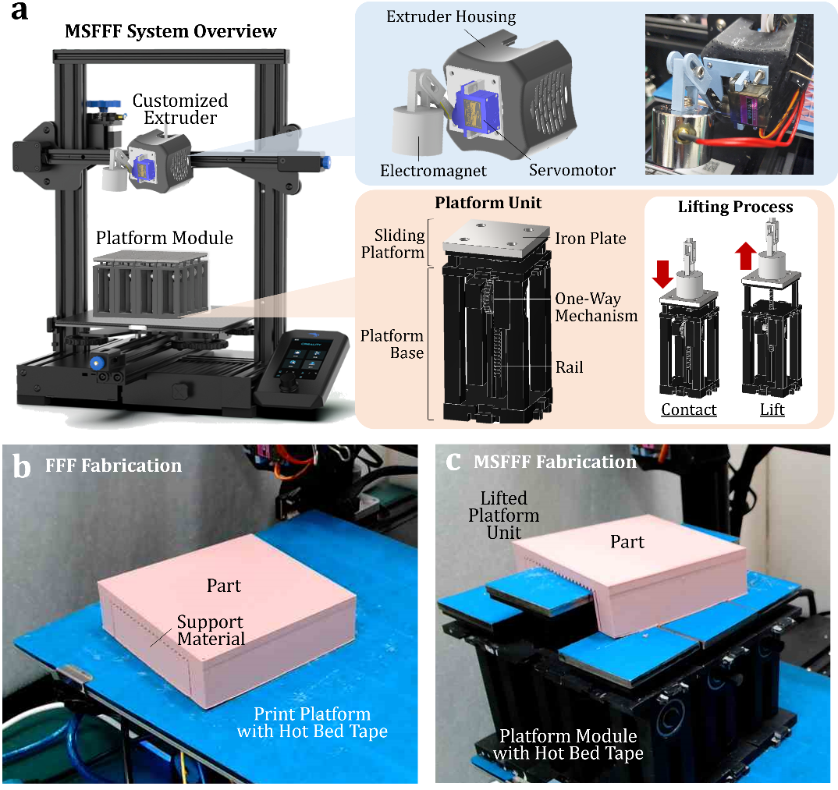

**Fig. 1.** MSFFF system and fabrication setup overview: (a) MSFFF system configuration, highlighting key components including the customized extruder and platform module. (b) Conventional FFF setup and fabricated part. (c) MSFFF setup and fabricated part.

Fig. 1(a) also presents the MSFFF extruder with a customized extruder housing. To achieve platform lifting, a servomotor-driven mechanism with an end-effector electromagnet was incorporated while maintaining the core functionality of the existing extruder. To initiate platform lifting, the extruder accurately positions the electromagnet above the designated platform unit. Subsequently, the servomotor is activated, lowering the electromagnet until contact is established with the iron plate. The resulting magnetic force then uplifts the sliding platform. In practice, a hot bed tape (as the blue coverings shown in Figs. 1(b) and 1(c)) was applied to the steel plate to maintain the required magnetic attraction while ensuring sufficient adhesion with the deposited material. By precisely controlling the extruder movement, the sliding platform can be elevated to any desired height, functioning as direct support for the printing part. Fig. 1(c) illustrates the anticipated outcome of the MSFFF system. Compared to conventional FFF fabrication (Fig. 1(b)), which necessitates substantial support materials for parts with high overhang angles (90°), the MSFFF system significantly reduces support material consumption by utilizing the lifted platform units to provide direct support to the printing part.

**2.2 MSFFF Support Minimization Algorithm**

A custom-designed support minimization algorithm (SMA) is developed in this study to optimize part printing within the MSFFF system. This SMA addresses part placement and orientation relative to individual platform unit dimensions. The discretization of the platform, defined by the dimensions of each platform unit, establishes the resolution for support material elimination regions. Furthermore, the SMA integrates custom extruder lifting motions into the existing G-code for the original part, minimizing the need for extensive software modifications. This allows for synchronized platform lifting during printing, ensuring the platform is elevated only when necessary and preventing interference with extruder material deposition. Fig. 2 presents a flowchart of the proposed algorithm.

A bridge-shaped part with the largest overhang angle (90°) and varying sizes was chosen as the test specimen to demonstrate the benefits of the MSFFF system. The computer-aided design (CAD) model of the part was processed with slicing software (Cura by Ultimaker, Utrecht, Netherlands) to generate the initial G-code for FFF printing. This G-code was then fed into the SMA, which consists of eight critical steps: Sampling, Assigning, Eliminating, Grouping, Comparing, Resampling, and Converging. Details of each step are as follows.

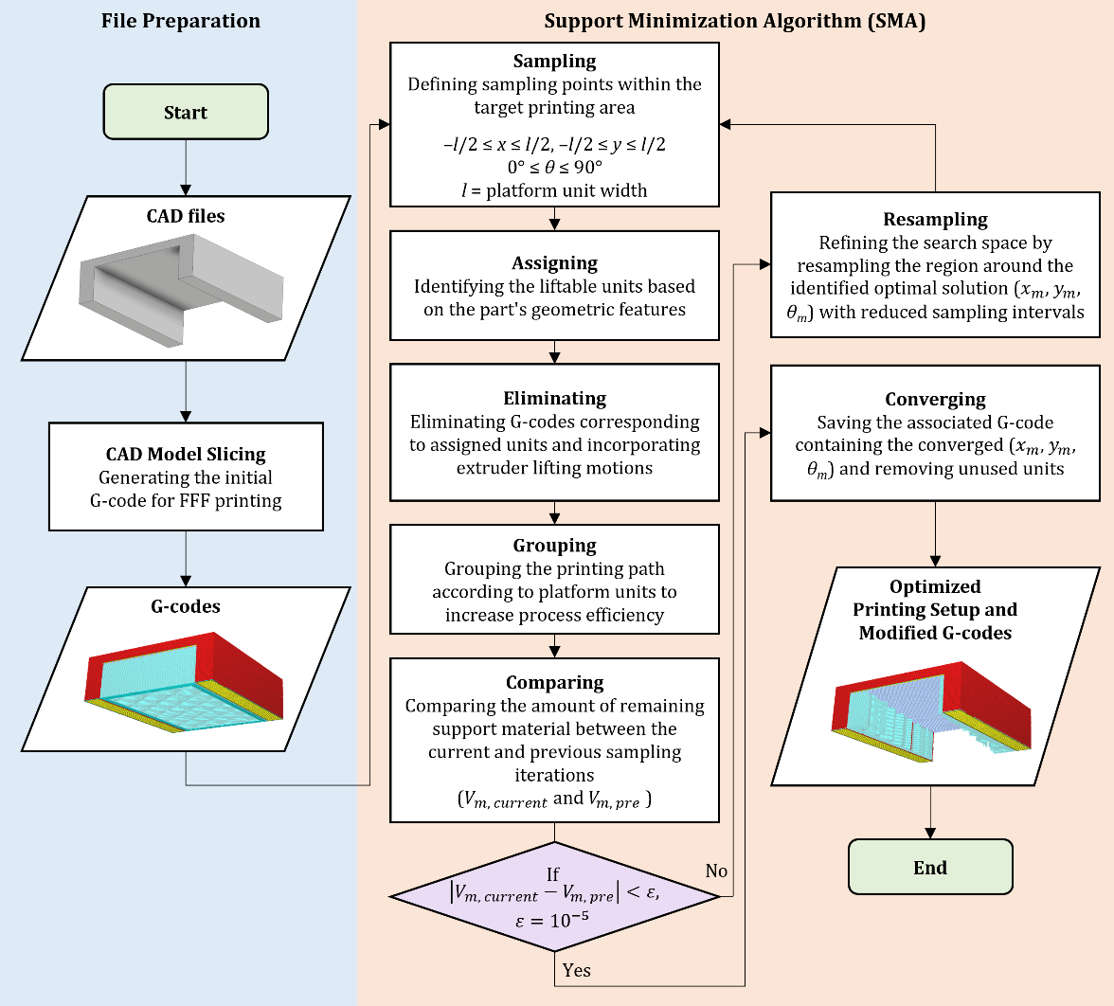

**Fig. 2.** Flowchart of the support minimization algorithm (SMA).

**2.2.1 Sampling**

The initial evaluation utilized the largest MSFFF print platform module (4x4 platform units) for a printable area of 204 mm x 204 mm. Due to the discrete nature of the platform units, part placement and orientation relative to the platform directly affect the number of liftable units (and consequently, the amount of support material replaced). Therefore, various part locations and orientations within the printable area were evaluated to identify the configuration minimizing support material usage. An optimization sampling strategy was employed to efficiently explore all feasible combinations.

The part's location and orientation relative to the platform can be represented as (*x*, *y,* *θ*). The initial part placement is centered on the platform, denoted as (0, 0, 0°). Leveraging the platform module's symmetry, the sampling space is restricted to –*l*/2≤ *x* ≤ *l*/2, –*l*/2≤ *y* ≤ *l*/2, and 0° ≤ *θ* ≤ 90°, where *l*/2 represents half the platform unit width (25.5 mm). This range encompasses all possible support elimination scenarios on this MSFFF platform. The sampling space is then uniformly divided with eight equal intervals for each variable, resulting in a sampling step size of Δ*x* = Δ*y* = *l*/8 = 6.375 mm and Δ*θ* = 90°/8 = 11.25°. This strategy yields a total of 512 unique combinations of (*x*, *y*, *θ*) for the first sampling.

**2.2.2 Assigning**

For each combination of (*x*, *y*, *θ*), the liftable platform units are identified based on their potential to support the part without introducing collisions. If a specific platform unit is entirely covered by a region requiring support structure in the part's geometry, it is designated as "liftable." Subsequently, the required lifting heights for these identified liftable units are assigned based on the part's geometric requirements. The remaining platform units, which will be partially or fully obscured by the part but not require support, remain at their initial positions, functioning as the standard printing platform.

**2.2.3 Eliminating**

Leveraging the locations and assigned heights of the identified liftable platform units, the corresponding regions in the original G-code for support material deposition that can be entirely eliminated were determined. Subsequently, these identified support regions are excluded by removing the corresponding G-code instructions. Concurrently, the designed extruder motions for achieving the desired lifting heights of each unit are translated into new G-code commands. These newly generated instructions are then integrated into the original G-code for synchronized execution.

**2.2.4 Grouping**

However, simply modifying the original G-code can lead to inefficiencies. The extruder head may traverse previously eliminated support regions, unnecessarily extending printing time and reducing process efficiency. To address this, the modified G-code is further optimized by rearranging the printing paths. G-code segments corresponding to a specific platform unit are grouped together, ensuring material deposition is completed within that unit before moving to the next. This approach streamlines the printing process and significantly reduces printing time. Ultimately, this process results in a set of modified G-code instructions with rearranged printing paths for each evaluated (*x*, *y*, *θ*) combination.

**2.2.5 Comparing**

Following the G-code modification, the estimated amount of remaining required support material can be calculated for each (*x*, *y*, *θ*) combination. The combination among the sampling points with the minimal support material requirement, denoted as (*xm*, *ym,* *θm*), is then identified. The corresponding support material amount is denoted as *V*m, current and compared to the minimum value obtained from the previous sampling iteration (*V*m, pre) to determine convergence. If this is the first sampling iteration, the minimum value is compared to a baseline value of zero (representing no support material reduction). If the difference between the current minimum and the previous minimum falls within a pre-defined convergence threshold (*ε* = 0.00001 in this study), it suggests convergence towards the global minimum (proceed to "Converging" step). Conversely, a larger difference indicates that the global minimum has not been reached, necessitating further optimization through resampling.

**2.2.6 Resampling**

To further refine the solution and potentially reach the global minimum, the region surrounding the identified (*xm*, *ym,* *θm*) with minimal support material is subjected to resampling. This commonly employs optimization technique focuses on exploring combinations near the local minimum. The resampling range is defined as *xm* ± Δ*x* (previous *x* step size), *ym* ± Δ*y* (previous *y* step size), and *θm* ± Δ*θ* (previous *θ* step size). This reduced range allows for a more targeted search while maintaining efficiency. Similar to the initial sampling, the resampled space is uniformly divided with eight equal divisions for each variable, generating new combinations of (*x*, *y,* *θ*) for evaluation. The process then iterates through the steps from "Assigning" to "Comparing" until the global minimum is identified.

**2.2.7 Converging**

Convergence of the results signifies the identification of the minimum required support material amount. The corresponding (*xm*, *ym,* *θm*) represents the optimal part location and orientation that minimizes support material usage through the designed platform unit lifting motions. The associated G-code is then saved for subsequent part printing. Furthermore, depending on the platform units ultimately utilized, any unused units can be removed for a more streamlined MSFFF system configuration.

**2.3 MSFFF Part Fabrication Procedures**

This investigation evaluated the functionality of the MSFFF system by integrating its components, a discretized platform module and a customized extruder housing, onto a commercially available FFF printer (Ender 3 V2, Creality). A custom Python interface was developed to synchronize the SMA-generated G-codes with commands for triggering the extruder housing's electromagnet, facilitating platform unit lifting (Fig. 3). All test cases employed polylactic acid (PLA) filaments under the following FFF printing parameters: feed rate of 50 mm/s, extruder temperature of 210 °C, and layer height of 0.28 mm. The detailed procedures of the MSFFF printing process are illustrated in Fig. 3. Prior to fabrication, a calibration step ensured platform flatness. Dimensional variations between individual platform units can lead to discrepancies in initial heights, ultimately impacting the final assembled platform's flatness. Calibration involved lifting each platform unit by a set distance of 15 mm, observing material deposition patterns, and adjusting initial heights until consistent deposition lines were achieved. This process resulted in a usable fabrication space of 220 mm x 220 mm x 80 mm. Following calibration, the SMA-generated G-codes were transferred to the FFF printer for part fabrication.

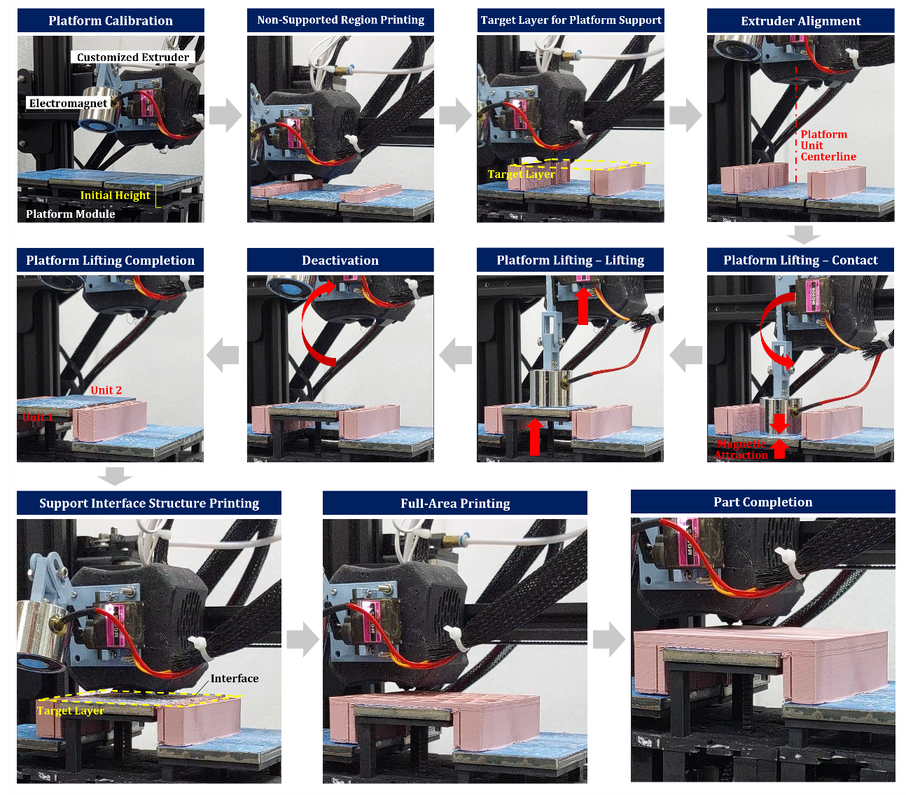

**Fig. 3.** Detailed procedures of the MSFFF fabrication process.

The initial printing phase focused on regions of the part and any residual support structures that did not require platform support. These regions were deposited directly onto the non-lifted platform units. Conversely, regions originally designated for support material were intentionally skipped to allow for subsequent lifting of those platform units. Upon reaching the target layer requiring platform support, material extrusion ceased, and the extruder head repositioned to align precisely with the center of the designated platform unit identified by the SMA. The custom software interface then initiated communication with the servomotor, triggering the lowering of the electromagnet until contact was established with the platform unit's steel plate. Subsequently, the electromagnet was activated, generating a magnetic force that attracted the platform unit. The extruder then lifted the platform to its pre-determined height, which was set slightly lower than the previously deposited layer. This deliberate gap facilitated the printing of a specially designed 4-layered interface structure on the lifted platform units. This interface structure enabled easy part removal after fabrication, minimizing the risk of damage to the platform units themselves. The electromagnet was then deactivated and moved to the next unit to repeat the lifting steps until all the required units are lifted (as exemplified by Units 1 and 2 in Fig. 3). Upon completion of platform lifting and interface structure deposition, which aligned seamlessly with the previous layer (target layer), material deposition resumed to finalize the part's geometry.

**2.4 Test Case Design**

To evaluate the effectiveness of the MSFFF system for parts with varying sizes and complex geometries, a bridge-like test part was designed. This part featured a 90-degree overhang angle, a feature typically requiring support material in conventional FFF printing, thus highlighting the capabilities of MSFFF (Fig. 4(a)). The initial bridge geometry measured 80 mm x 80 mm x 25 mm (length x width x height), with a deck thickness of 5 mm and pier width of 10 mm. Subsequent test parts were created by uniformly scaling this starting geometry at varying ratios (starting from 1x with 0.2 spacing) up to 2.2x. This scaling approach allowed for investigation of the interplay between part size and the interaction with the MSFFF platform module (Fig. 4(a)) as the part size directly influences the number of platform units requiring lifting.

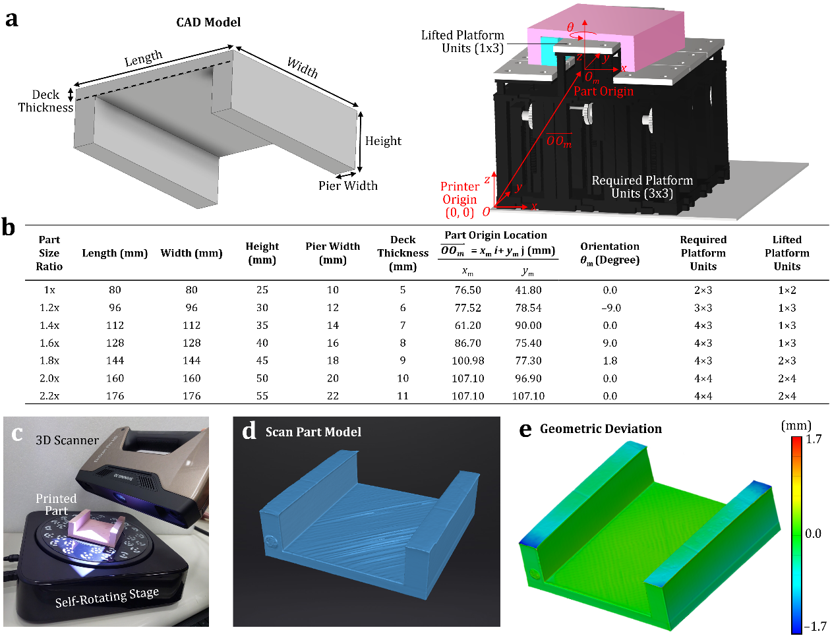

**Fig. 4.** Test part geometries, MSFFF setup, and geometric accuracy evaluation: (a) Test part geometry and experimental setup. (b) Test part parameters and MSFFF configuration. (c) Dimensional accuracy evaluation setup. (d) Scan part model. (e) Geometric deviation analysis.

Figure 4(b) summarizes the dimensional parameters, origin locations, and orientations of test parts, as derived from the CAD model and SMA-processed G-codes. It also details the required platform units, including those designated for lifting in support regions and those remaining stationary for complete printing. Each test part possesses a unique set of (*xm*, *ym,* *θm*) coordinates generated by the SMA. Since the MSFFF platform module was integrated onto a commercially available FFF platform, the test part origin's location relative to the original FFF platform origin (denoted as *O*, the G-code origin) is represented as *O*m (*x*m+2*l*, *y*m+2*l*), where *l* signifies the platform unit length. An additional parameter, *θm*, denotes the part's orientation around the z-axis. This crucial shifting information (denoted as $\overset{⃑}{OO_{m}}$ in Fig. 4(b)) is applied when executing the SMA-processed G-codes, ensuring the FFF extruder precisely reaches the (*xm*, *ym*) coordinates. The observations revealed that the total number of required platform units generally increased with increasing part size (ratio). However, the number of lifted units exhibited a dependence on both part size and its interaction with the platform unit size. In some instances, regions requiring platform support were insufficiently large to accommodate additional lifted platform units. This set of comprehensively designed test cases enables thorough investigation of these factors and provides a robust foundation for evaluating the performance of the MSFFF system.

**2.5 Evaluation of MSFFF Performance**

The aforementioned test parts were fabricated on both the MSFFF system and the original FFF system (without the MSFFF platform module) under identical positioning and orientation to evaluate dimensional accuracy, fabrication time, and material usage for each system. Each fabrication was repeated 3 times to evaluate the system consistency and robustness. Dimensional accuracy is a critical indicator for MSFFF, as it ensures not only time and material savings but also the preservation of functional and geometric fidelity in the fabricated parts. A 3D scanner (EinScan Pro HD, Shining 3D, Hangzhou, China) was employed to scan the parts fabricated using both MSFFF and FFF (Fig. 4(c)). During scanning, designated marker points were strategically attached to the part surfaces to serve as reference points for subsequent geometric comparisons. Each scanned part was transformed into a point cloud and exported as a surface model for further analysis (Fig. 4(d)). The scanning data was processed using 3D scanning software (GOM, Zeiss, Oberkochen, Germany) and compared to the ideal 3D model to quantify geometric deviations (Fig. 4(e)). This software facilitated the identification and measurement of the maximum error, serving as a performance indicator for MSFFF in subsequent analyses.

Fabrication time and material usage for each specimen under both printing conditions (MSFFF and FFF) were measured to compare their performance. To isolate the effect of MSFFF on support material printing, data were collected for both the entire printing process and support material printing alone. Fabrication time was recorded by initiating timers within the software interface during the execution of unmodified G-codes (FFF) and SMA-processed G-codes (MSFFF). This approach enabled straightforward measurement of total printing time versus support material fabrication time, as the G-codes explicitly specify the printing region. Material usage was quantified by measuring the weight of each specimen. Following fabrication, the specimen was detached from the platform, and any required support material was separated from the main part for individual weighing using an electronic scale (AB623, SHINKO DENSHI, Tokyo, Japan). This process allowed for the separate quantification of total part weight and support material weight for further investigation.

1. **Results and Discussions**

**3.1 Analysis of Material Usage and Fabrication Time**

Fig. 5 presents the results for total material usage (including both the part and support material) and support material usage alone (to emphasize the reduction in support usage) for FFF and MSFFF printing. Each bar chart in Fig. 5 summarizes the average weight values and standard deviations obtained from three trials for test parts with varying size scaling ratios (1x, 1.2x, 1.4x, 1.6x, 1.8x, 2x, and 2.2x). The reduction in material usage for MSFFF compared to FFF is quantified as a reduction percentage, defined as [(FFF weight) - (MSFFF weight)] / (FFF weight). This reduction percentage is represented by the orange curve in Fig. 5. Additionally, Fig. 5 presents photographic documentation of MSFFF-fabricated parts in their final state. Results demonstrate a significant overall reduction in material usage for MSFFF compared to FFF, encompassing both total and support weight across all part scaling ratios investigated in this study. This implies that the developed MSFFF system exhibits a proven capability for substantially replacing support material requirements for various geometries traditionally requiring them in FFF printing. The consistently small standard deviations observed across three trials further highlight the robustness and reliability of the MSFFF system.

The following discussion analyzes the results using scaling ratio and reduction percentage. For total weight measurements, MSFFF achieved an impressive average reduction percentage of 25.36%, with a maximum of 35.96%, across all tested ratios. Material usage for both FFF and MSFFF increased with the scaling ratio; however, MSFFF consistently yielded lower weight values in all cases. From a 1x to 1.6x scaling ratio, a decreasing trend in reduction percentage was observed, ranging from 25.25% to 17.28%. This variation can be attributed to the part's location and orientation determined by the SMA (refer to Section 2.4). As shown in the setup photos in Fig. 5, the size of the platform units limited the regions where support material could be replaced by these units. For example, the 1x part's bottom deck surface was fully supported by a single row of platform units. However, the 1.6x part's surface area exceeded the combined surface area of a single row of platform units, yet it was not large enough to accommodate two rows. Consequently, some support material remained necessary to support regions lacking platform unit support. This phenomenon is reflected in the decreased reduction percentage values, even though the actual material usage for MSFFF remained lower than FFF. Once the part size reached a 1.8x scaling ratio, the bottom surface became large enough to accommodate an additional row of platform units, as evident in the 1.8x setup photo. This resulted in a significant increase in the reduction percentage to 35.96% (the maximum observed in this study), highlighting the superior material efficiency of MSFFF compared to FFF. It is noteworthy that although both 1x and 1.8x cases achieved complete support material replacement, they utilized the same amount of interface structure for stable material adhesion and damage-free removal (refer to Session 2.3). However, the 1.8x part exhibited a higher reduction percentage due to its larger overall material usage (resulting in a proportionally smaller contribution from the interface structure). From a 1.8x to 2.2x scaling ratio, the expected decreasing trend in reduction percentage was again observed due to the aforementioned limitation of platform unit size. Nevertheless, the consistently lower material usage for MSFFF compared to FFF suggests that the system remains advantageous as part size increases.

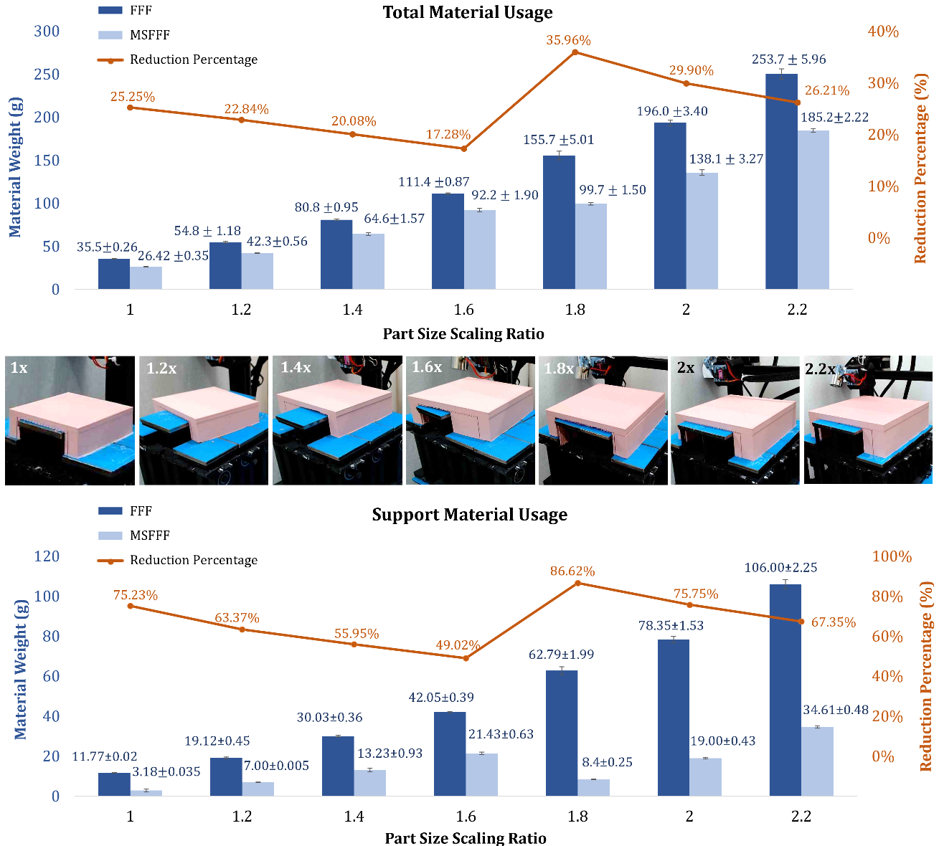

**Fig. 5.** Material usage comparison between FFF and MSFFF for varying part sizes.

The analysis of support material weight measurements mirrored the trends observed for total weight measurements, attributable to the inherent connection between support material and overall part weight. However, MSFFF exhibited a considerably more impressive performance in reducing support material usage, achieving an average reduction percentage of 67.61% across all tested ratios. This value peaked at 86.62%, further highlighting the outstanding capability of the MSFFF system in minimizing support material requirements. This significant reduction can be attributed to the core functionality of the MSFFF system: replacing support structures with strategically positioned, movable platform units. By directly lifting specific part regions during printing, the need for conventionally generated support material is substantially diminished or even eliminated entirely, as demonstrated in the successful complete support material replacement for the 1x and 1.8x parts (see Fig. 5).

Fig. 6 presents the results for total part fabrication time (encompassing both part and support material printing) and support material fabrication time alone for FFF and MSFFF printing. Each bar chart in Fig. 6 summarizes the average time values and standard deviations obtained from three trials for test parts with varying size scaling ratios (1x, 1.2x, 1.4x, 1.6x, 1.8x, 2x, and 2.2x). Similar to the weight measurements, the reduction in fabrication time is again quantified as a reduction percentage , depicted by the orange curve in Fig. 6. The results consistently demonstrate a significant overall reduction in fabrication time for MSFFF compared to FFF, accompanied by minimal standard deviations.

For total fabrication time, MSFFF achieved an average reduction percentage of 20.57%, with a maximum of 32.79%, across all tested ratios. Fabrication time increased with the scaling ratio for both FFF and MSFFF; however, MSFFF consistently exhibited lower time values in all cases. Unlike the weight reduction trend, the reduction in fabrication time did not exhibit a continuous decrease from 1x to 1.6x ratios. This divergence can be attributed to the focus of the proposed SMA method on minimizing support material usage, not directly optimizing fabrication time. Fabrication time is also influenced by printing parameters and assigned printing paths. Cases with minimized support material may require slightly longer fabrication times compared to others. For example, as shown in the setup photos in Fig. 6, the 1.2x part's orientation resulted in remaining support material distributed across both pier sides, while the 1.4x part concentrated support material towards the left pier. This concentration in the 1.4x part allowed for shorter nozzle movements per layer, leading to a larger reduction in time compared to the 1.2x part. This phenomenon is reflected in an additional inflection point in the reduction percentage curve between 1.2x and 1.4x in Fig. 6. A similar inflection point is observed between 2x and 2.2x for cases requiring two rows of platform units.

The analysis of support fabrication time mirrored the trends observed for total fabrication time, as the time to print support material directly influences overall printing duration. MSFFF achieved a significantly more impressive average reduction percentage of 46.49% (with a maximum of 71.58%) for support fabrication time compared to total fabrication time. This finding underscores the enhanced efficiency of MSFFF in minimizing not only support material usage but also the dedicated printing time required for support structures. This translates to a more streamlined and time-saving printing process.

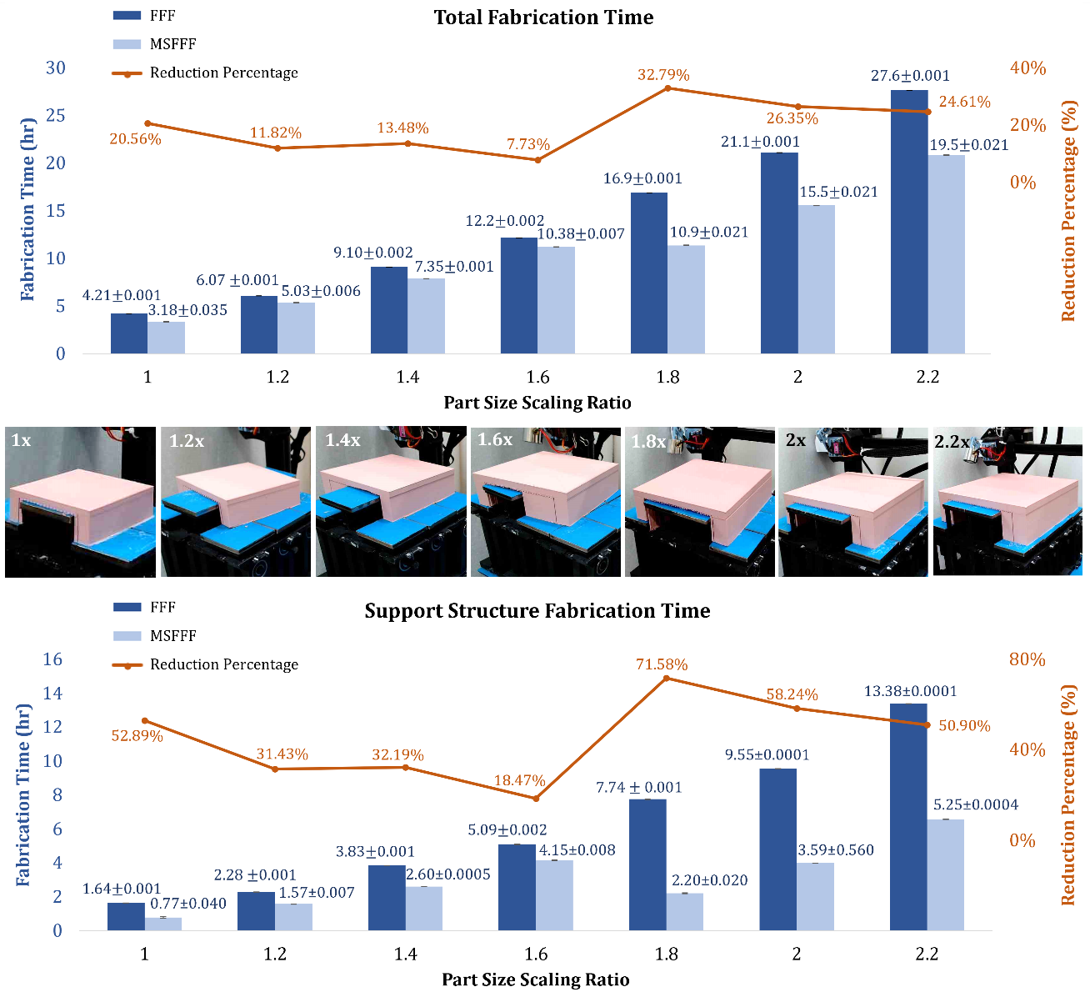

**Fig. 6.** Fabrication time comparison between FFF and MSFFF for varying part sizes.

The presented results highlight a limitation of the current MSFFF system: the fixed size of the platform units restricts their ability to replace support material for all geometries. Future efforts will focus on developing solutions to address this limitation. One potential approach involves miniaturization of the platform unit surface area, effectively increasing the system's resolution. Alternatively, the design of special mechanisms that dynamically adjust the platform unit surface size and shape based on specific geometric requirements could be explored to maximize the benefits of MSFFF. Nevertheless, this study demonstrates that the developed MSFFF system offers significant reductions in material usage and fabrication time. This translates to reduced material waste, less labor-intensive post-processing, and increased overall productivity. Additionally, the portability of the MSFFF system and the minimal machine modifications required for its implementation enhance its accessibility, potentially fostering wider adoption within industrial applications.

**3.2 Geometrical Accuracy Evaluation**

3D scanning software was employed to analyze the scan data of parts fabricated by both FFF and MSFFF systems, quantifying their geometric deviations from the ideal 3D model. Figs. 7 and 8 present the results for scaling ratios ranging from 1x to 2.2x. Color bars represent the level of geometric deviations, with red and blue highlighting positive and negative deviations relative to the 3D model CAD files, respectively. Additionally, Figs. 7 and 8 showcase photographs of the fabricated parts at the end of printing (on the platform) and in their final state (with support materials removed) to visually compare the printing quality of both systems. It is important to note that some minor surface bumps are observed in both fabrication methods. These bumps are not printing defects but rather the result of strategically placed black feature stickers used for scanning calibration and positioning (as shown on the actual parts).

Overall, the quality of specimens from FFF and MSFFF was highly comparable, exhibiting only minor differences in surface texture. Both methods produced parts that were mostly geometrically accurate compared to the 3D CAD model (indicated by predominantly green areas in the Figs. 7 and 8). The maximum geometric deviations, ranging from –0.43 mm to –1.7 mm across all scaling ratios, consistently occurred at corners for both FFF and MSFFF (as shown in Figs. 7 and 8). Corner warping, a common FFF printing error, is responsible for these larger errors. It arises due to poor layer adhesion to the print platform and the temperature difference associated with the material phase change (melted PLA to solidified PLA). To ensure a fair comparison, the heating function of the FFF system's heat bed was deactivated, and the current low-cost MSFFF system prototype lacked a heating function. Consequently, the warping phenomenon became more pronounced, although it remained primarily confined to corners and had minimal impact on structural integrity. Another region with larger geometrical deviations was the bottom surface of each part, primarily caused by the removal of support material across a large area. Lastly, no clear trend in geometric deviations was observed with increasing scaling ratio, suggesting that the geometric dimension accuracy remains consistent with MSFFF processing and may even be applicable to larger specimens or printers.

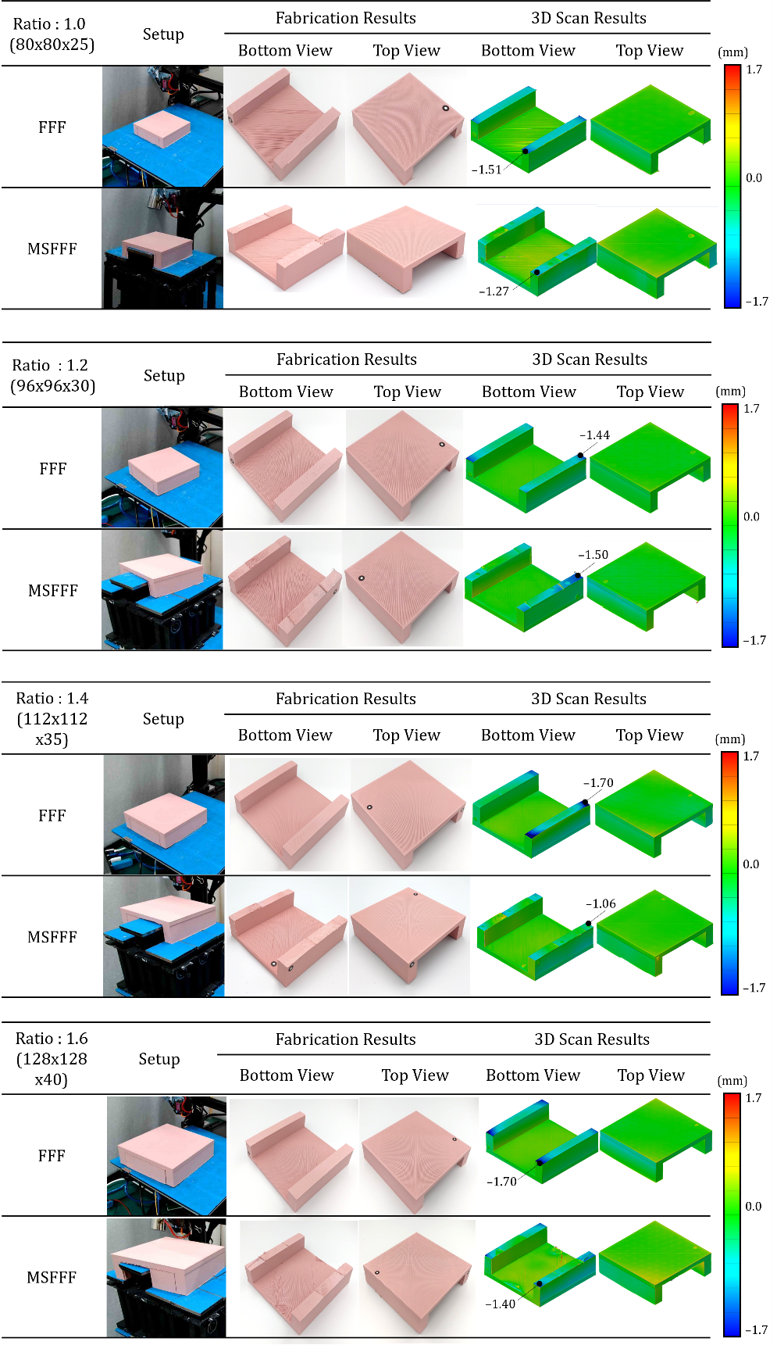

**Fig. 7.** FFF and MSFFF process and part analysis: build completion setup, detailed part inspection, and 3D scan results (part size scaling ratios 1.0 to 1.6).

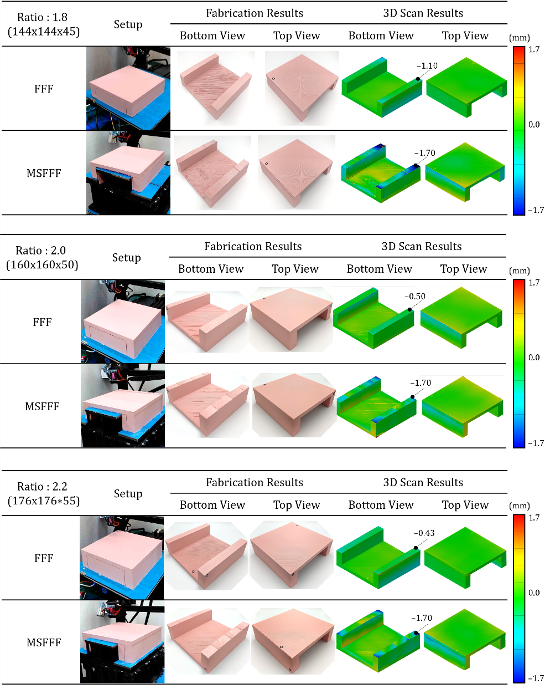

**Fig. 8.** FFF and MSFFF process and part analysis: build completion setup, detailed part inspection, and 3D scan results (part size scaling ratios 1.8 to 2.2).

However, minor defects were observed in both FFF and MSFFF fabricated parts, with MSFFF exhibiting some limitations due to its platform unit design. Fig. 9 presents magnified views of the 1.2x, incorporating actual part photographs and corresponding 3D scan results for detailed analysis. The corner warping phenomenon is evident in the blue areas of the FFF-fabricated part (Fig. 9(a)), as previously discussed. While such defects have minimal impact on mechanical strength and functionality (most surface areas remain smooth), they are worth noting for real-world applications. The MSFFF-fabricated part (Fig. 9(b)) exhibited similar corner warping, along with additional material protrusion features absent in the FFF part. The circular features highlighted in Regions 1 and 3 were caused by countersunk holes for fastening the iron plate onto the platform unit. The edge-like features in Region 2 arose from clearance gaps between platform units, implemented to prevent platform interference during lifting motions. These unavoidable defects in this study slightly affected surface quality but did not significantly impact overall geometric completeness. Future iterations of the MSFDM system should investigate the use of metal components to minimize assembly tolerances and further enhance surface finish.

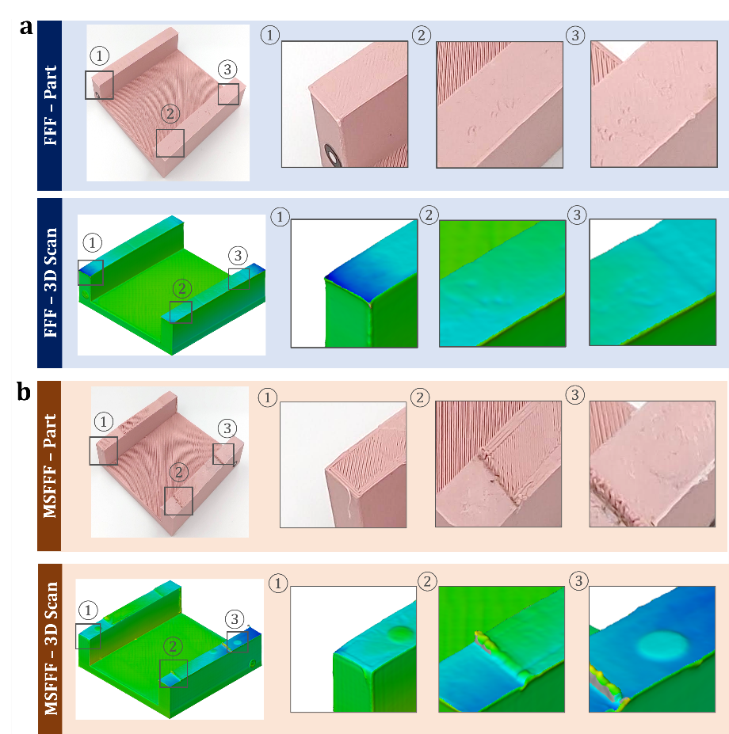

**Fig. 9.** Comparative analysis of FFF and MSFFF parts at 1.2x scale: photographic and 3d scan magnifications.

In conclusion, the MSFFF system demonstrates geometric accuracy comparable to, and in some cases exceeding, that of a commercial FFF machine. This finding is particularly significant considering the substantial reductions in material usage and fabrication time achieved by MSFFF. While both methods exhibited minor surface defects, those associated with the MSFFF platform unit design resulted in only slight texture variations. Importantly, these imperfections do not significantly compromise the overall geometric fidelity or functionality of the parts, thus minimally impacting their mechanical strength.

**3.3 Case Studies: Stepped Structure and Turbine Blade**

To further assess the adaptability and generalizability of the MSFFF system for fabricating parts with intricate geometries, case studies were conducted using two distinct geometries: a stepped structure and a turbine blade (Fig. 10). Fig. 10(a) shows the 4-stepped structure employed in this study, featuring a height of 5 mm and a width of 10 mm for each step. This structure was specifically designed with two turns to facilitate multi-platform lifting within a compact part profile. The selection aimed to maximize the benefits of MSFFF, as the SMA processing is anticipated to nearly eliminate the need for support materials (Fig. 10(b)) compared to FFF (Fig. 10(c)). Fig. 10(f) illustrates the turbine blade used in this study, with a thickness of 1 mm, a length of 25 mm, and a width of 5 mm. This thin blade possesses a continuously changing 3D curvature, designed to test the limitations of the MSFFF system in a more demanding fabrication scenario (Fig. 10(h)). Additionally, this case study represents an industrial product, allowing for the evaluation of MSFFF's feasibility in industrial applications. Case studies were conducted using the two aforementioned geometries to evaluate the performance of MSFFF and FFF. Figs. 10(d), 10(e), 10(i), and 10(j) present photographs (top and bottom views with magnified details) of the fabricated parts alongside their corresponding 3D scanning results, providing qualitative insights into geometric deviations. A detailed breakdown of material usage, fabrication time, and the resulting reduction percentage for each case in both FFF and MSFFF is provided in Table 1.

The stepped structure served as a clear demonstration of MSFFF's capabilities. The MSFFF achieved a substantial reduction in total material usage (26.67%) and fabrication time (35.66%) compared to FFF. This success stems from the near-complete elimination of support material usage (87.23% reduction) and fabrication time dedicated to support material printing (80.70% reduction) by the lifted platform units in MSFFF (Fig. 10(c)). The minimal required support material usage (0.6 g) in MSFFF can be attributed to the 4-layered support interface (described in Session 2.3), crucial for platform adhesion and part removal without damage. Both systems yielded visually indistinguishable printing surface quality and geometric completeness, as evidenced by the low geometric deviations (predominantly green areas) in the 3D scanning results (Figs. 10(d) and 10(e)). The corner warping phenomenon, previously attributed to the non-heated print platform (Session 3.2), was observed in both parts, with minimal negative errors (–0.7 mm and –0.5 mm for MSFFF and FFF, respectively). Additionally, minor positive errors (yellow regions) were present in both systems, likely due to slight surface damage during support material removal. Despite these minor imperfections, the stepped structure was accurately fabricated in both systems, with MSFFF offering significant advantages in material usage and fabrication time.

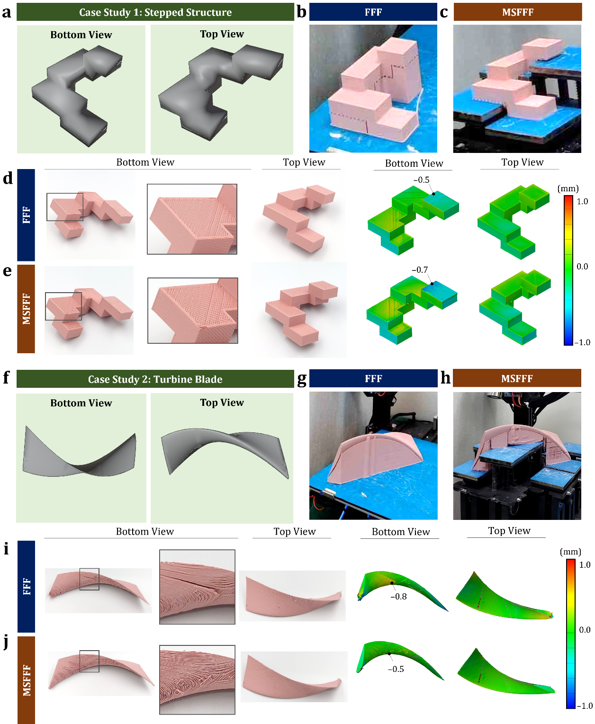

**Fig. 10.** Comparative analysis of FFF and MSFFF in case studies: (a) CAD model of stepped structure. Stepped structure fabrication completion in (b) FFF and (c) MSFFF. Detailed part inspection and 3D scan results for stepped structure in (d) FFF and (e) MSFFF. (f) CAD model of turbine blade. Turbine blade fabrication completion in (g) FFF and (h) MSFFF. Detailed part inspection and 3D scan results for turbine blade in (i) FFF and (j) MSFFF.

**Table 1**. Comparative analysis of material usage, fabrication time, and reduction percentages for FFF and MSFFF.

|  |  |  |  |  |  |  |  |  |  |
| --- | --- | --- | --- | --- | --- | --- | --- | --- | --- |
| Stepped Structure | Blade | Total Fabrication Time (hr) | | Total Material Usage (g) | | Support Structure Fabrication Time (hr) | | Support Material Usage (g) | |
| FFF | | 1.99 | 7.34 | 14.70 | 40.98 | 0.88 | 4.48 | 4.70 | 23.49 |
| MSFFF | | 1.28 | 5.80 | 10.78 | 25.89 | 0.17 | 2.80 | 0.60 | 9.29 |
| Reduction Percentage | | 35.66% | 20.99% | 26.67% | 36.82% | 80.70% | 37.44% | 87.23% | 60.45% |

The turbine blade case study further validated the effectiveness of MSFFF. Although continuous surface curvature and platform unit size limitations necessitated the use of support material in MSFFF, the system still achieved a considerable reduction in material usage (36.82% for total and 60.45% for support) and fabrication time (20.99% for total and 37.44% for support) compared to FFF. This improvement can be attributed to the lifted platform units replacing a substantial portion of the support material (Fig. 10(h)) originally required by FFF (Fig. 10(g)). While both FFF and MSFFF fabricated parts exhibited good geometric accuracy (low geometric deviations - mostly green), as shown in Figs. 10(i) and 10(j), the benefits of reduced support material usage were evident in the post-processing stage. During support material removal in FFF, the support materials created a large separation force on the thin part geometry, leading to deformation and damage on the bottom surface (Fig. 10(i)). In contrast, MSFFF minimized this effect by requiring less support material (Fig. 10(j)), resulting in a reduced separation force during removal. This is reflected in the 3D scanning results, with a lower maximum error on the bottom surface for MSFFF (0.5 mm positive error) compared to FFF (0.8 mm). These results demonstrate the confirmed capability and generalizability of MSFFF for fabricating complex parts. In summary, the MSFFF produces printing quality comparable to FFF while significantly reducing material usage and fabrication time. This technology further offers particular advantages for fabricating thin parts, minimizing surface damage, and simplifying post-processing due to the reduced need for support material.

1. **Conclusions**

This study presents the development and evaluation of a novel FFF additive manufacturing system: the minimized-support FFF (MSFFF) system. MSFFF tackles the challenge of support structures by strategically positioning and lifting individual platform units using an innovative hardware design. This design integrates seamlessly with a dedicated SMA control software strategy that optimizes part printing positions and orientations to minimize support material requirements. Through experimentation, this study demonstrates the outstanding capabilities of MSFFF in fabricating parts with varying geometries, including simple bridge-like structures with high overhang angles, and parts with complex geometries (stepped structures and turbine blades). Compared to a commercial FFF machine, MSFFF achieved successful and accurate part fabrication across all test cases, with substantial reductions in total material usage (ranging from 20% to 40%) and fabrication time. Reductions in support material usage and fabrication time were even more impressive, with most cases achieving a remarkable 70% to 85% decrease. Furthermore, MSFFF yielded satisfactory printing quality comparable to FFF, as evidenced by the overall low geometric deviations observed in 3D scanning results. While both FFF and MSFFF exhibited minor surface defects, the discretized platform design of MSFFF introduced additional slight surface imperfections. However, these imperfections had minimal impact on the final geometric completeness, suggesting no significant compromise on the resultant part functionality and mechanical strength.

Two specially designed case studies with complex part geometries were conducted to further assess MSFFF's capability and generalizability. The stepped structure case serves as a prime example, highlighting the system's potential with near-complete elimination of support material, achieving a maximum reduction of 87.20% and 80.7% in support material usage and fabrication time, respectively. These results emphasize the potential of MSFFF for minimizing waste and production time, particularly when fabricating parts with features that traditionally require significant support structures. Additionally, the fabricated parts exhibited comparable geometric accuracy with minimal deviations, demonstrating the system's ability to produce high-quality parts. While minor surface imperfections were observed in both methods, MSFFF offered the advantage of minimizing surface damage during post-processing, especially for thin parts like the turbine blade tested in this study. This benefit stems from the reduced separation force associated with less support material usage.

Future work will focus on addressing the limitations identified in the current MSFFF system to further enhance its performance. Firstly, the ability to minimize support material usage is currently limited by the discrete platform unit design. To address this, two potential solutions will be explored: reducing the size of each unit to increase resolution and implementing a special mechanism on the platform assembly for dynamically adjusting individual platform unit size and shape based on specific part geometry requirements. Secondly, the current AM-printed polymer platform components will be investigated for potential replacement with precisely machined metal parts. This shift would improve assembly accuracy, enabling precise lifting motions and potentially mitigating the need for gaps with lager clearances between units that can slightly compromise printing quality. Additionally, the FFF printing path could be modified to incorporate a gap-filling strategy to compensate for any necessary gaps for assembly purposes. Lastly, integrating heating elements into the MSFFF platform units is envisioned to mitigate corner warping by promoting a more uniform temperature distribution, thereby enhancing material adhesion and structural integrity. Additionally, this apterproach could enable the fabrication of materials with high thermal deformation rates, which are susceptible to thermal effects during the FFF process.

In conclusion, this study successfully demonstrates MSFFF, that utilizes a collaborative approach between software algorithms and a discretized platform, can significantly reduce support structure requirements. This translates to substantial savings in fabrication time and material consumption. The findings suggest that MSFFF is a promising and generalizable technology with the potential to revolutionize the efficiency and sustainability of FFF and potentially other MEX processes, particularly for fabricating complex parts with intricate geometries. The modular design of MSFFF components fosters portability and high compatibility with existing commercial FFF machines, potentially enabling straightforward adoption within industrial applications. The technologies developed in this work hold promise for broader applicability across various AM methods that struggle with support material usage and removal, including vat polymerization and powder bed fusion. This advancement signifies a significant step forward in the additive manufacturing field, promoting the wider adoption and application of this technology across various industries.

# References

[1] Pereira T, Kennedy J V., Potgieter J. A comparison of traditional manufacturing vs additive manufacturing, the best method for the job. Procedia Manuf, vol. 30, Elsevier B.V.; 2019, p. 11–8. https://doi.org/10.1016/j.promfg.2019.02.003.

[2] Bourell DL. Perspectives on Additive Manufacturing. Annu Rev Mater Res 2016;46:1–18. https://doi.org/10.1146/annurev-matsci-070115-031606.

[3] Praveena BA, Lokesh N, Buradi A, Santhosh N, Praveena BL, Vignesh R. A comprehensive review of emerging additive manufacturing (3D printing technology): Methods, materials, applications, challenges, trends and future potential. Mater Today Proc, vol. 52, Elsevier Ltd; 2022, p. 1309–13. https://doi.org/10.1016/j.matpr.2021.11.059.

[4] Attaran M. The rise of 3-D printing: The advantages of additive manufacturing over traditional manufacturing. Bus Horiz 2017;60:677–88. https://doi.org/10.1016/j.bushor.2017.05.011.

[5] Alfaify A, Saleh M, Abdullah FM, Al-Ahmari AM. Design for additive manufacturing: A systematic review. Sustainability (Switzerland) 2020;12. https://doi.org/10.3390/SU12197936.

[6] Huang Y, Leu MC, Mazumder J, Donmez A. Additive manufacturing: Current state, future potential, gaps and needs, and recommendations. Journal of Manufacturing Science and Engineering, Transactions of the ASME 2015;137. https://doi.org/10.1115/1.4028725.

[7] Conner BP, Manogharan GP, Martof AN, Rodomsky LM, Rodomsky CM, Jordan DC, et al. Making sense of 3-D printing: Creating a map of additive manufacturing products and services. Addit Manuf 2014;1:64–76. https://doi.org/10.1016/j.addma.2014.08.005.

[8] Bhatia A, Sehgal AK. Additive manufacturing materials, methods and applications: A review. Mater Today Proc, vol. 81, Elsevier Ltd; 2021, p. 1060–7. https://doi.org/10.1016/j.matpr.2021.04.379.

[9] Li Y, Su C, Zhu J. Comprehensive review of wire arc additive manufacturing: Hardware system, physical process, monitoring, property characterization, application and future prospects. Results in Engineering 2022;13. https://doi.org/10.1016/j.rineng.2021.100330.

[10] Fidan I, Naikwadi V, Alkunte S, Mishra R, Tantawi K. Energy Efficiency in Additive Manufacturing: Condensed Review. Technologies (Basel) 2024;12. https://doi.org/10.3390/technologies12020021.

[11] May G, Psarommatis F. Maximizing Energy Efficiency in Additive Manufacturing: A Review and Framework for Future Research. Energies (Basel) 2023;16. https://doi.org/10.3390/en16104179.

[12] Tomar B, Shiva S, Nath T. A review on wire arc additive manufacturing: Processing parameters, defects, quality improvement and recent advances. Mater Today Commun 2022;31. https://doi.org/10.1016/j.mtcomm.2022.103739.

[13] Waller JM, Saulsberry RL, Parker BH, Hodges KL, Burke ER, Taminger KM. Summary of NDE of additive manufacturing efforts in NASA. AIP Conf Proc, vol. 1650, American Institute of Physics Inc.; 2015, p. 51–62. https://doi.org/10.1063/1.4914594.

[14] Radhika C, Shanmugam R, Ramoni M, Bk G. A review on additive manufacturing for aerospace application. Mater Res Express 2024;11. https://doi.org/10.1088/2053-1591/ad21ad.

[15] Keshavarz MK, Gontcharov A, Lowden P, Chan A, Kulkarni D, Brochu M. Turbine blade tip repair by laser directed energy deposition additive manufacturing using a rene 142–merl 72 powder blend. Journal of Manufacturing and Materials Processing 2021;5. https://doi.org/10.3390/jmmp5010021.

[16] Strickland JD. Applications of Additive Manufacturing in the Marine Industry. 2016.

[17] Singh BJ, Sehgal R, Singh RP. Additive manufacturing in biomedical and healthcare sector: an umbrella review. International Journal on Interactive Design and Manufacturing 2023. https://doi.org/10.1007/s12008-023-01524-0.

[18] Salmi M. Additive manufacturing processes in medical applications. Materials 2021;14:1–16. https://doi.org/10.3390/ma14010191.

[19] Sammaiah P, Chaitanya Krishna D, Sai Mounika S, Rajasri Reddy I, Karthik T. Effect of the Support Structure on Flexural Properties of Fabricated Part at Different Parameters in the Fdm Process. IOP Conf Ser Mater Sci Eng, vol. 981, IOP Publishing Ltd; 2020. https://doi.org/10.1088/1757-899X/981/4/042030.

[20] Griffiths CA, Howarth J, De Almeida-Rowbotham G, Rees A, Kerton R. A design of experiments approach for the optimisation of energy and waste during the production of parts manufactured by 3D printing. J Clean Prod 2016;139:74–85. https://doi.org/10.1016/j.jclepro.2016.07.182.

[21] Jaisingh Sheoran A, Kumar H. Fused Deposition modeling process parameters optimization and effect on mechanical properties and part quality: Review and reflection on present research. Mater Today Proc, vol. 21, Elsevier Ltd; 2020, p. 1659–72. https://doi.org/10.1016/j.matpr.2019.11.296.

[22] Onwubolu GC, Rayegani F. Characterization and Optimization of Mechanical Properties of ABS Parts Manufactured by the Fused Deposition Modelling Process. International Journal of Manufacturing Engineering 2014;2014:1–13. https://doi.org/10.1155/2014/598531.

[23] Mohamed OA, Masood SH, Bhowmik JL. Optimization of fused deposition modeling process parameters: a review of current research and future prospects. Adv Manuf 2015;3:42–53. https://doi.org/10.1007/s40436-014-0097-7.

[24] Karunakaran KP, Bernard A, Suryakumar S, Dembinski L, Taillandier G. Rapid manufacturing of metallic objects. Rapid Prototyp J 2012;18:264–80. https://doi.org/10.1108/13552541211231644.

[25] Udroiu R, Braga IC, Nedelcu A. Evaluating the quality surface performance of additive manufacturing systems: Methodology and a material jetting case study. Materials 2019;12. https://doi.org/10.3390/ma12060995.

[26] Golhin AP, Tonello R, Frisvad JR, Grammatikos S, Strandlie A. Surface roughness of as-printed polymers: a comprehensive review. International Journal of Advanced Manufacturing Technology 2023;127:987–1043. https://doi.org/10.1007/s00170-023-11566-z.

[27] Bhuvanesh Kumar M, Sathiya P. Methods and materials for additive manufacturing: A critical review on advancements and challenges. Thin-Walled Structures 2021;159. https://doi.org/10.1016/j.tws.2020.107228.

[28] Karmuhilan M, Kumanan S. Mechanical Anisotropy and Failure Analysis of Inconel 625 Parts Manufactured Using Wire and Arc Additive Manufacturing (WAAM). Journal of Failure Analysis and Prevention 2024;24:583–90. https://doi.org/10.1007/s11668-024-01860-7.

[29] Weaver JS, Rosenthal I. Understanding anisotropic tensile properties of laser powder bed fusion additive metals : 2021. https://doi.org/10.6028/NIST.AMS.100-44.

[30] Mumtaz K, Vora P, Hopkinson N. A METHOD TO ELIMINATE ANCHORS/SUPPORTS FROM DIRECTLY LASER MELTED METAL POWDER BED PROCESSES. 2011.

[31] Jiang J, Xu X, Stringer J. Support structures for additive manufacturing: A review. Journal of Manufacturing and Materials Processing 2018;2. https://doi.org/10.3390/jmmp2040064.

[32] Jiang J, Ma Y. Path planning strategies to optimize accuracy, quality, build time and material use in additive manufacturing: A review. Micromachines (Basel) 2020;11. https://doi.org/10.3390/MI11070633.

[33] Fahraz Ali, Boppana V. Chowdary, Justin Maharaj. Influence of Some Process Parameters on Build Time, Material Consumption, and Surface Roughness of FDM Processed Parts: Inferences Based on the Taguchi Design of Experiments. IAJC; 2014.

[34] Abdulhameed O, Al-Ahmari A, Ameen W, Mian SH. Additive manufacturing: Challenges, trends, and applications. Advances in Mechanical Engineering 2019;11. https://doi.org/10.1177/1687814018822880.

[35] Guo X, Zhou J, Zhang W, Du Z, Liu C, Liu Y. Self-supporting structure design in additive manufacturing through explicit topology optimization. Comput Methods Appl Mech Eng 2017;323:27–63. https://doi.org/10.1016/j.cma.2017.05.003.

[36] Wu C, Wan B, Entezari A, Fang J, Xu Y, Li Q. Machine learning-based design for additive manufacturing in biomedical engineering. Int J Mech Sci 2024;266. https://doi.org/10.1016/j.ijmecsci.2023.108828.

[37] Gardan J. Additive manufacturing technologies: State of the art and trends. Int J Prod Res 2016;54:3118–32. https://doi.org/10.1080/00207543.2015.1115909.

[38] Singh B, Kumar R, Singh Chohan J. Multi-objective optimization of 3D Printing process using genetic algorithm for fabrication of copper reinforced ABS parts. Mater Today Proc, vol. 48, Elsevier Ltd; 2021, p. 981–8. https://doi.org/10.1016/j.matpr.2021.06.264.

[39] Valerga AP, Batista M, Salguero J, Girot F. Influence of PLA filament conditions on characteristics of FDM parts. Materials 2018;11. https://doi.org/10.3390/ma11081322.

[40] Camposeco-Negrete C. Optimization of printing parameters in fused deposition modeling for improving part quality and process sustainability. The International Journal of Advanced Manufacturing Technology 2020;108:2131–47. https://doi.org/10.1007/s00170-020-05555-9/Published.

[41] Lv N, Ouyang X, Qiao Y. Adaptive Layering Algorithm for FDM‐3D Printing Based on Optimal Volume Error. Micromachines (Basel) 2022;13. https://doi.org/10.3390/mi13060836.

[42] Arobli M, Taghizadieh N, Yaghmaei-Sabegh S, Azar SZ. Optimizing additive manufacturing: Minimizing support structures through constraint-based design. Structures 2024;63. https://doi.org/10.1016/j.istruc.2024.106379.

[43] Vanek J, Galicia JAG, Benes B. Clever support: Efficient support structure generation for digital fabrication. Eurographics Symposium on Geometry Processing, vol. 33, Eurographics Association; 2014, p. 117–25. https://doi.org/10.1111/cgf.12437.

[44] Strano G, Hao L, Everson RM, Evans KE. A new approach to the design and optimisation of support structures in additive manufacturing. International Journal of Advanced Manufacturing Technology 2013;66:1247–54. https://doi.org/10.1007/s00170-012-4403-x.

[45] Jiang J, Xu X, Stringer J. A New Support Strategy for Reducing Waste in Additive Manufacturing. 2018.

[46] Jiang J, Xu X, Stringer J. Optimization of process planning for reducing material waste in extrusion based additive manufacturing. Robot Comput Integr Manuf 2019;59:317–25. https://doi.org/10.1016/j.rcim.2019.05.007.

[47] Coupek D, Friedrich J, Battran D, Riedel O. Reduction of Support Structures and Building Time by Optimized Path Planning Algorithms in Multi-axis Additive Manufacturing. Procedia CIRP, vol. 67, Elsevier B.V.; 2018, p. 221–6. https://doi.org/10.1016/j.procir.2017.12.203.

[48] Wüthrich M, Gubser M, Elspass WJ, Jaeger C. A novel slicing strategy to print overhangs without support material. Applied Sciences (Switzerland) 2021;11. https://doi.org/10.3390/app11188760.

[49] Kontovourkis O, Tryfonos G. Robotic 3D clay printing of prefabricated non-conventional wall components based on a parametric-integrated design. Autom Constr 2020;110. https://doi.org/10.1016/j.autcon.2019.103005.

[50] Tang P, Zhao X, Shi H, Hu B, Ding J, Yang B, et al. A review of multi-axis additive manufacturing: Potential, opportunity and challenge. Addit Manuf 2024;83. https://doi.org/10.1016/j.addma.2024.104075.

[51] Murtezaoglu Y, Plakhotnik D, Stautner M, Vaneker T, Van Houten FJAM. Geometry-Based Process Planning for Multi-Axis Support-Free Additive Manufacturing. Procedia CIRP, vol. 78, Elsevier B.V.; 2018, p. 73–8. https://doi.org/10.1016/j.procir.2018.08.175.

[52] Hrib V-F, Chifan F, Ciorap M, Dumitraş CG. An Study Regarding a New Concept of 3D Printing Using a 6 Axis Industrial Robotic ARM. Bulletin of the Polytechnic Institute of Iași Machine Constructions Section 2023;69:85–98. https://doi.org/10.2478/bipcm-2023-0026.

[53] Jensen ML, Mahshid R, D’Angelo G, Walther JU, Kiewning MK, Spangenberg J, et al. Toolpath strategies for 5DOF and 6DOF extrusion-based additive manufacturing. Applied Sciences (Switzerland) 2019;9. https://doi.org/10.3390/app9194168.

[54] Hongyao S, Xiaoxiang Y, Jianzhong F. Research on the flexible support platform for fused deposition modeling. International Journal of Advanced Manufacturing Technology 2018;97:3205–21. https://doi.org/10.1007/s00170-018-2046-2.

[55] Xu Y, Wang Z, Gong S, Chen Y. Reusable support for additive manufacturing. Addit Manuf 2021;39. https://doi.org/10.1016/j.addma.2021.101840.